Smart Bookstand

<Final Report>

Jeong Soo Yi

ECE4313

Table of Contents

1. Abstract
2. Project Concept
3. Parts Selection
4. Parts Evaluation
5. Design
6. Prototyping
7. Contributions
8. Appendix
9. Sources Cited
10. Abstract

The smart bookstand seeks to innovate your reading experience. Imagine you’re on your bed, trying to read your favorite book. You have and LED on and you lay on your bed on your back. You realize that the LED light does not shine on your page, but only shines on the back of the book. This is something that happened to me too many times. I’ve tried flipping the LEDs, try and get a small reading light, and so on: nothing really worked. Then came the idea of innovating the best tool for reading: the bookstand.

Bookstands are right now simply those wooden blocks that you lean your book on, adjust the tilt of the stand and read without having to bend your neck downward. It is dull, it is not smart, and it does not guarantee nothing more. I thought, why not add lighting system into the bookstand? And why not make it portable for people to easily attach it to the book and assist in the reading experience?

Less and less people are reading books, and the advent of e-books and portable devices did not resolve the reading problem. I believe that Smart Bookstand is the right solution. One of the strongest feedbacks on the e-book market was that the reading experience that they cherished was diminished when the market transferred into the e-book field. The book should stay the same, while the peripherals should get better. Why have the books turn into tablets, but not have any of the devices used to read books get better?

1. Project Concept

The system is basically a touch enabled light on the sides of a device that would luminate the pages based on 1. Where the user is reading (which basically means where the user’s hands are located, and 2. Depending on the level of ambient lighting.

The bookstand will be an adjustable, portable device that can attach to mostly all sizes of books given, having the extendable legs. There are 3 major functions implemented within the device:

1. Turn on RGB LEDs in various color and strength
2. Detect the level of ambient lighting
3. Recognize where the user touches to turn on the LED at that position

What shocked me the most was that no product like this was made in the market[1]. This means that a market is open for exploration, which made me decide to engage in this project.

1. Parts Selection

These are 3 major functions implemented within the device:

1. Turn on LEDs in various color and strength
2. Detect the ambient light
3. Locate the touch position

The following are the parts exploration and the selection criteria for the final parts chosen:

1. Turn on LEDs in various color and strength

This feature requires that the LED at the sides of the bookstand will aid the reading experience of the users. In order to do this the LED must support:

1. Different levels of light intensity
2. Adjustable RGB

The following is the comparison of the parts I researched (Final Decision is colored in green):

|  |  |  |  |  |  |  |  |
| --- | --- | --- | --- | --- | --- | --- | --- |
|  | **Product Name** | **Dimension(mm)** | **Need a power more then 5V?** | **Cost (per Unit)** | **Used in Lab? (Ease of Access&Use)** | **Note(Extra Requirements?)** | **Link** |
| 1 | LTRBR37G-4R4S-0125-0-2-R18 Osram Opto RGB LED | 1 x 1 x 0.25 | No | $1.03 | No | Dimension too small, need too much in  quantity to fill the bookstand dimension | [Link](https://www.mouser.com/ProductDetail/OSRAM-Opto-Semiconductors/LTRBR37G-4R4S-0125-0-2-R18?qs=sGAEpiMZZMseGfSY3csMkdgyOOAg6kv2vsmy5%2F56tY8yzKLgrOXTgQ%3D%3D) |
| 2 | SMLVN6RGB1U1 Standard LEDs - SMD RGB | 3.5 x 2.8 x 0.6 | No | $0.99 | No | Operating Supply Voltage is 2.5 to 5.5V,  might be costly in terms of voltage and current | [Link](https://www.mouser.com/ProductDetail/ROHM-Semiconductor/SMLVN6RGB1U1?qs=sGAEpiMZZMseGfSY3csMkZhfb9Ek0xqwasG93utC5i8ahuuuE5AmPw%3D%3D) |
| 3 | YSL-R1047CR4G3BW-F8 RED/GREEN/BLUE Tricolor LED | 11 x 10Ø | No | $1.05 | Yes | Common anode RGB LED connected to GND Translucent bulb | [Link](http://cdn.sparkfun.com/datasheets/Components/General/YSL-R1047CR4G3BW-F8.pdf) |
| 4 | YSL-R596CR3G4B5C-C10 RGB LED Common Cathode | 8.7 x 5Ø | No | $2.05 | Yes | Common cathode RGB LED connected to Vcc Transparent bulb | [Link](https://www.sparkfun.com/datasheets/Components/YSL-R596CR3G4B5C-C10.pdf) |

The common RGB LEDs used in the lab is sufficient for the use of this functionality. There are two LEDs used in the lab, a common anode RGB LED and a common cathode RGB LED. I also inspected other types of LEDs, since a square type LED would fit better to the side of a bookstand. Yet, the square LEDs are too small in size to cover all the sides of the bookstand, this means that the LED is way too weak to use as assisting light in reading experience, making it an unlikely choice to use in this product. Among the other options, the common cathode LED was chosen because the light intensity was much greater than the common anode LED.

1. Detect the ambient light

The ambient light level should be detected so that the lighting could be adjusted according to the ambient light level. Therefore, I researched on ambient light sensors, as well as looking into photoresistors. There was a photoresistor used in the lab, so that was a consideration. The following is the comparison of parts I considered (Final Decision is colored in green):

|  |  |  |  |  |  |  |  |
| --- | --- | --- | --- | --- | --- | --- | --- |
|  | **Product Name** | **Dimension(mm)** | **Need a power more then 5V?** | **Cost (per Unit)** | **Used in Lab? (Ease of Access&Use)** | **Note(Extra Requirements?)** | **Link** |
| 1 | TEPT5700 Ambient Light Sensor | 5 x 5.7 x 5.7 | Not Mentioned | $0.65 | No |  | [Link](https://www.mouser.com/ProductDetail/Vishay-Semiconductors/TEPT5700?qs=sGAEpiMZZMtsvOs01uN7U4QObnDMrrsgBPdqJbi9cyM%3D) |
| 2 | ALS-PT204-6C/L177 Ambient Light Sensor | Ø4mm x 5.2mm | 2.5 to 5.5V | $0.40 | No | Operating Supply Voltage is 2.5 to 5.5V,  might be costly in terms of voltage and current | [Link](https://www.arrow.com/en/products/als-pt204-6cl177/everlight-electronics) |
| 3 | GL5528 Photoresistor | 4.3 x 5.1 | No | $0.95 | Yes |  | [Link](https://www.adafruit.com/product/161?gclid=EAIaIQobChMI9JmL6sPE5gIVAWKGCh278gVlEAQYASABEgJulPD_BwE) |

In the end, there was an ease of access to the photoresistor, since the component was used in lab. This also meant that the manual was supplied sufficiently for use. Therefore, the photoresistor was chosen as the final product

1. Locate the touch position

For this functionality, I was looking into force resistive sensors and touch buttons. Along with this, the professor recommended a linear potentiometer. The following is the comparison of the products (Final Decision is colored in green):

|  |  |  |  |  |  |  |  |
| --- | --- | --- | --- | --- | --- | --- | --- |
|  | **Product Name** | **Dimension(mm)** | **Need a power more then 5V?** | **Cost (per Unit)** | **Used in Lab? (Ease of Access&Use)** | **Note(Extra Requirements?)** | **Link** |
| 1 | 30-81794 Force Resistive Sensor | Ø5.08mm | No | $8.64 | Yes  (In a previous Course) | Expensive to implement  in multiple areas(Need at least 8 of them) | [Link](https://www.digikey.com/product-detail/en/interlink-electronics/30-81794/1027-1001-ND/2476468) |
| 2 | DFRobot SEN0297 Pressure Sensor | Ø5.6mm | No | $3.09 | No | Need in large quantities to fill the dimensions of the side | [Link](https://www.digikey.com/product-detail/en/dfrobot/SEN0297/1738-SEN0297-ND/10136551) |
| 3 | Linear Soft Potentiometer | Length: 140.6 Width: 20.50 Thickness: 0.58mm | No | $7.95 | No | Expensive, but covers a  large area (Need 4) | [Link](https://www.adafruit.com/product/178) |

After some thought, the Linear Soft Potentiometer was decided. This could cover a long area with varying values of resistance depending on where you touched. This meant that the position of touch could be determined by the resistance value from the SoftPot, and the light from the corresponding position could be turned on.

1. Parts Evaluation
2. RGB LEDs

The LEDs were tested to make sure they have enough light level. The common cathode and the common anode LEDs were tested. Among the common anode LED and the common cathode LED, the common anode LED had a transparent bulb while the common cathode LED had a translucent LED. Since the final product will have a translucent shell to create a linear array of lighting, the transparent bulb is more fit than the translucent bulb, since the intensity of light will decrease too much with two layers of translucent shell on top of the lighting.

1. Ribbon Softpot sensor

The Soft Potentiometer (SoftPot) was tested using an MCP3008 ADC. The Vcc and GND pins were each connected to a 3.3V and Ground using a 10kOhm resistor. The collector had a pull-up resistor of 100kOhm, and was connected to the ADC. The collector from the SoftPot showed that the values read on the ADC varied from about 800 to 300, which was a translated value of bit values read through the registers of the SoftPot.

1. Photoresistor

The photoresistor was also tested using an MCP3008 ADC. One side of the photoresistor was connected to the ADC with a pull-up resistor of 10kOhm, and the other side was connected to Ground. The testing showed that the values varied depending on the level of light from 0 to 1023. The value was a 10-bit value, and common values varied from 300 to 950 because the ambient light could not be completely dark or completely bright.

1. Design

The Smart Bookstand has 3 major components: the RGB LEDs, the Ribbon Softpot sensor, and a photoresistor. The RGB LEDs are connected using a sn74hc595 shift register, and the analog sensors (photoresistor & ribbon SoftPot) are connected by using an MCP3008 ADC.

There are 8 RGB LEDs, each connected to the three shift registers. For each LED, the Red is all connected to one shift register, the Blue are all connected to another shift register, and all the Green are all connected to the other shift register. Since each shift register has 8 output pins, three shift registers can handle 8 RGB LEDs. The shift registers will be connected to the Pi using SPI1 connection, which has to be enabled with 3 chip enables. Each shift register will correspond to a Chip Enable, and the MOSI and CLK lines will be connected together.

For Analog input signals, I will use a photoresistor and four Linear SoftPot. They will all be connected to the MCP3008 ADC, using channels 0 to 4. In channel 0, the photoresistor will be connected. One side will be connected to ch0 with a pull-up resistor of 10kOhm, and the other side will be connected to ground. The four SoftPots each need to be connected to channels 1-4 of the MCP3008 ADC, each with a pull-up resistor of a 100kOhms. The Vcc line is connected to the 3.3V line on the Pi, and the GND is connected to ground, each with a resistor of 10kOhm connected. The MCP3008 is connected to the Pi using SPI0, Chip Enable 0.

1. Prototype

So for the perfboard creation, I came to the conclusion that there would be a necessity of two perfboards, one on top of another, because the given size of the perfboards was not big enough to contain the entire device. There were 7 connections needed in the total system of the shift registers and the RGB LEDs: Vcc, GND, MOSI, CLK, CE0, CE1, and CE2. So the solution was to have wires from the bottom perfboard (the ADC) and have female pins on the perfboard with the shift register and the LEDs so that this could be connected when the boards are put together.

For the prototype, only two LEDs were implemented in the schematic, since two was the number to show that I could control the color on both LEDs at different timing. If two worked, eight could definitely work. In addition, I noticed that the brightness of the LEDs dimmed as the number of LEDs increased. Therefore, I would include an additional power supply in the final product with the 8 LEDs, but for this prototype I decided to include two.

The photo of the perfboard is not included, but it was created and is included in the final physical submission. However, it did not function with the perfboard attached, so I had to recreate the breadboard in order to function the demo. As it is shown on the schematic of the second board, connecting three shift registers was a difficult task, and the connection could have been put wrong at that time. Here are the schematics of the two perfboards:

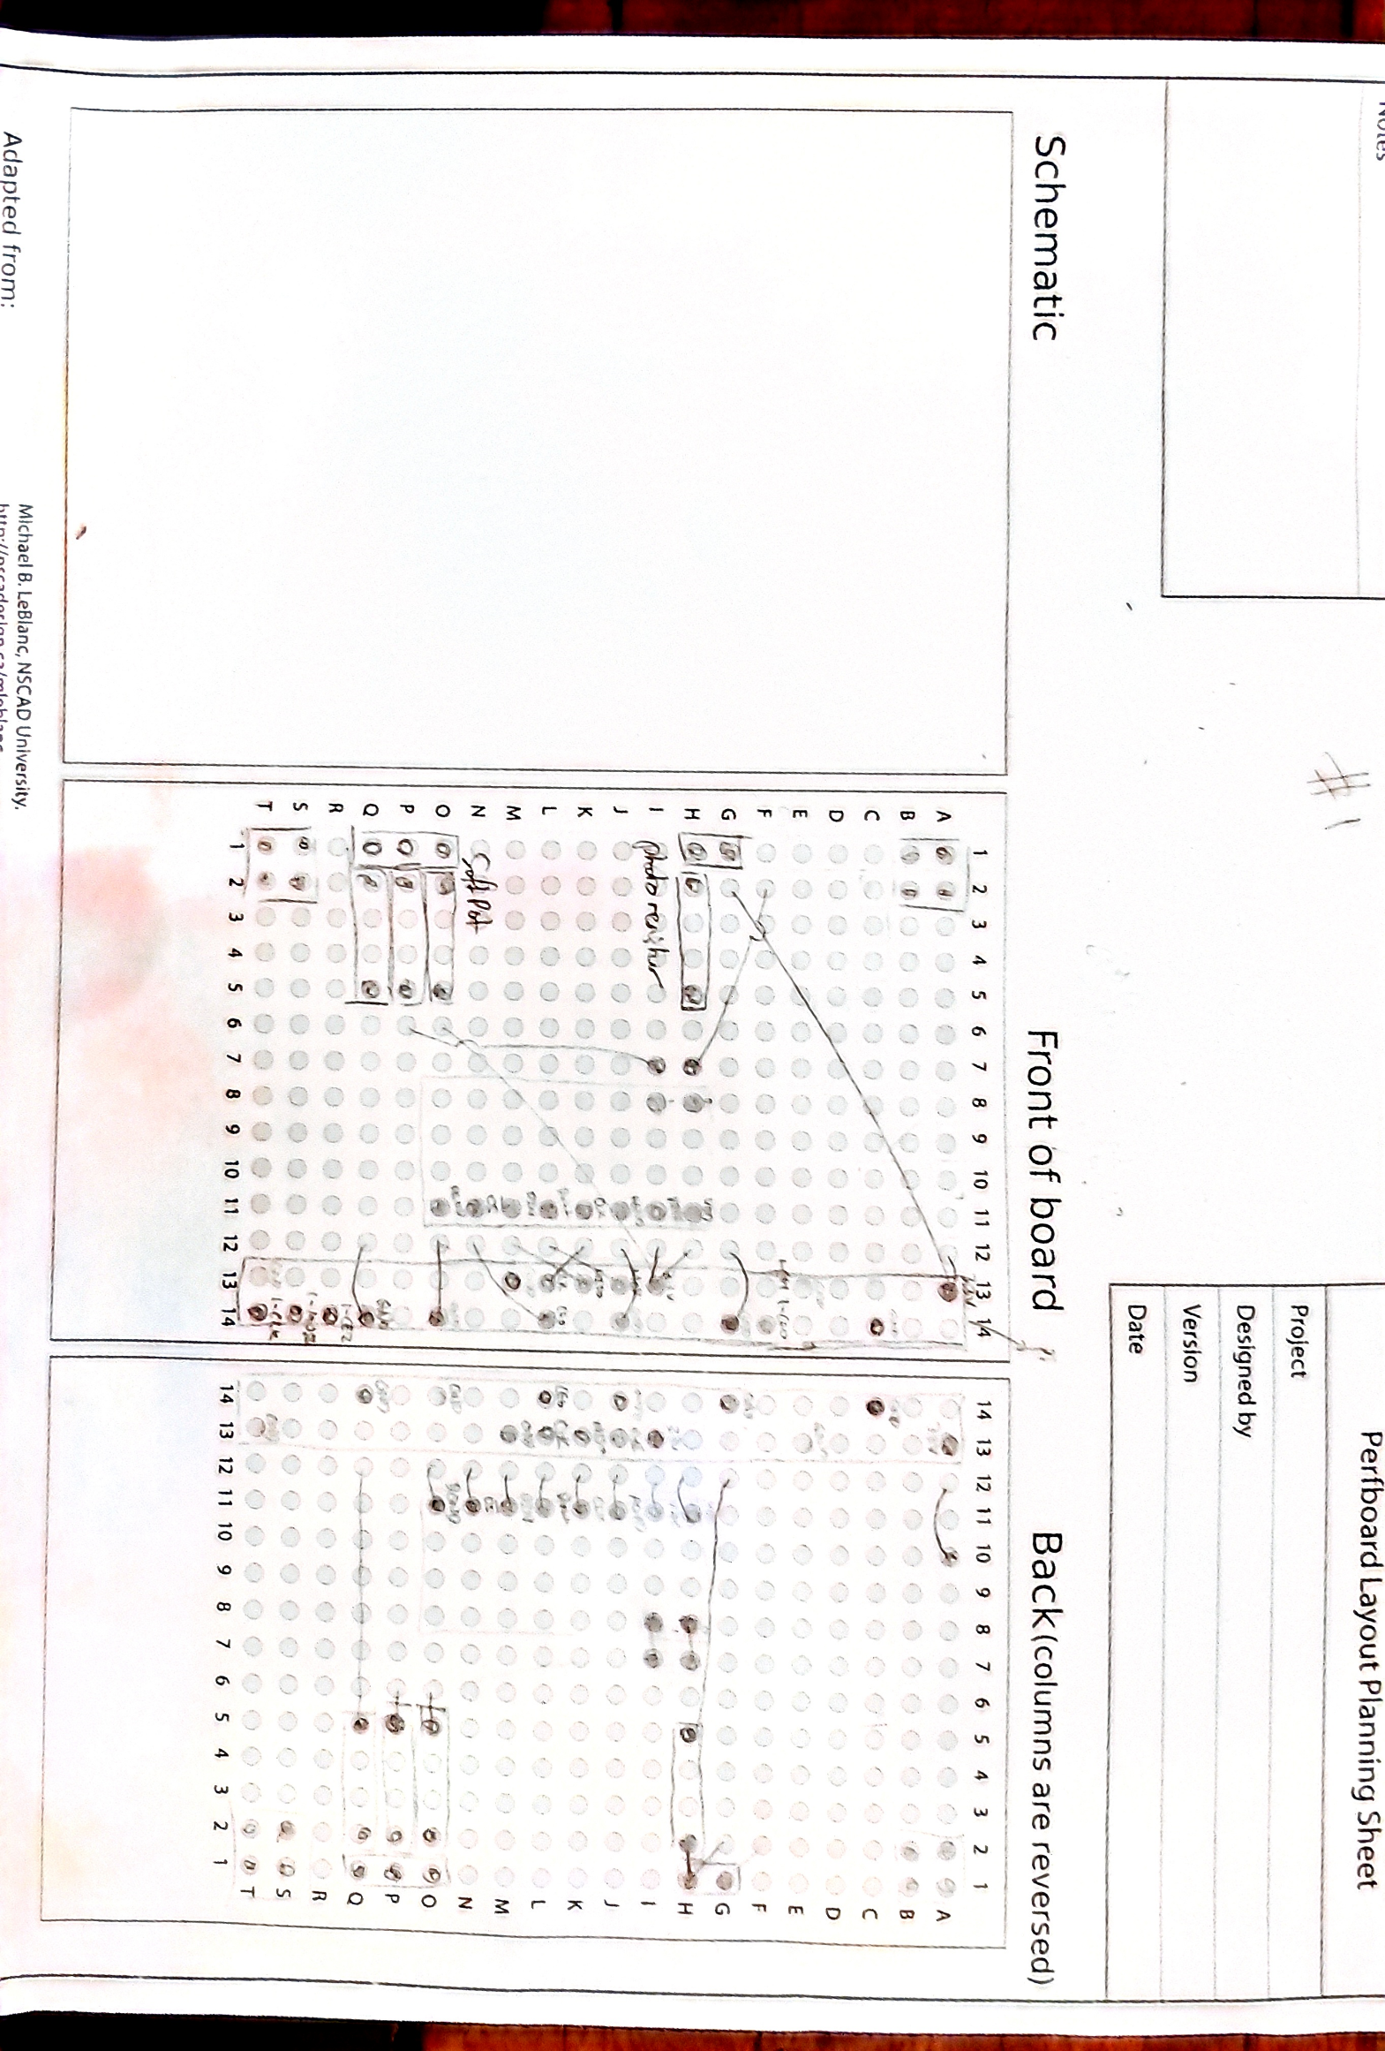Board 1(Connected to the pi, and on the bottom. Deals with ADC, photoresistor, and the SoftPot)

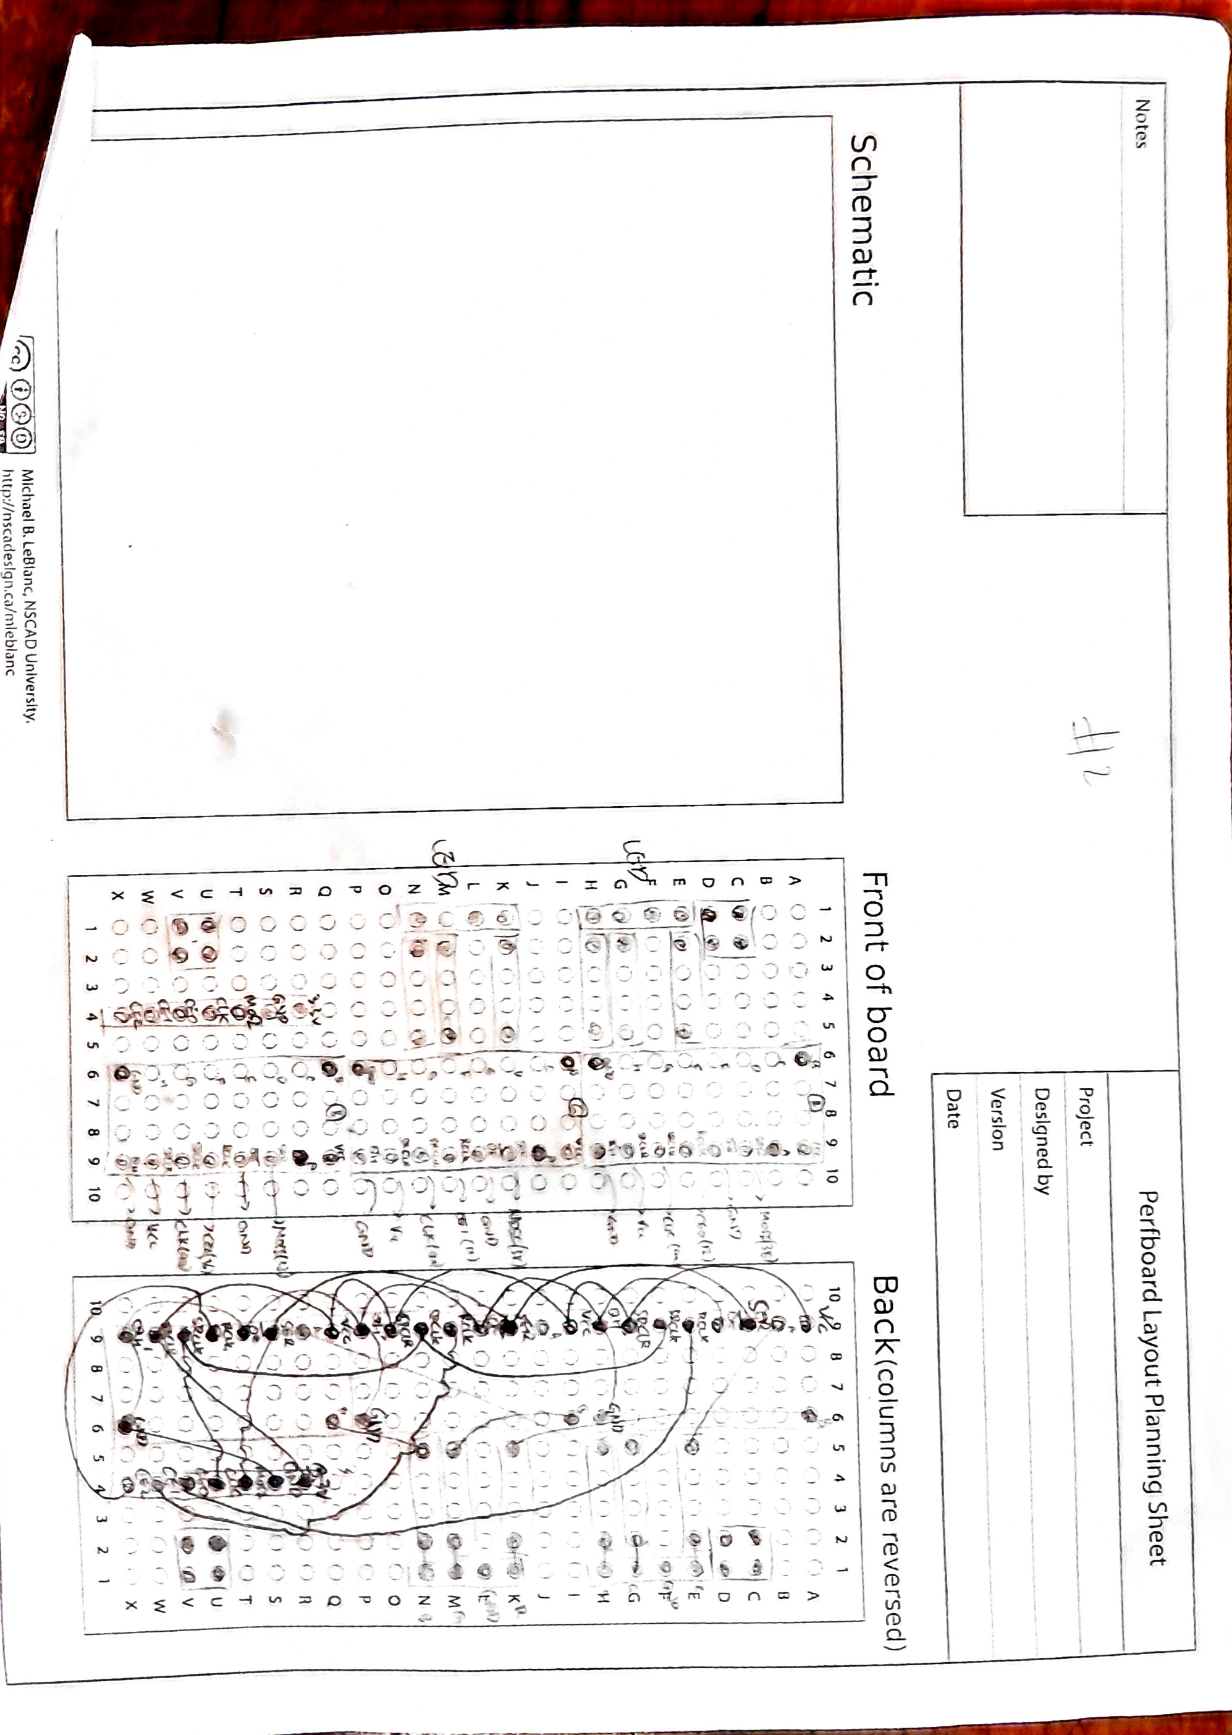Board 2 (Connected on top of Board 1, deals with RGB LED and the shift registers)

1. Contributions

This was a project done my one person, so contributions is not applicable.

1. Appendix
2. Fritzing Diagram

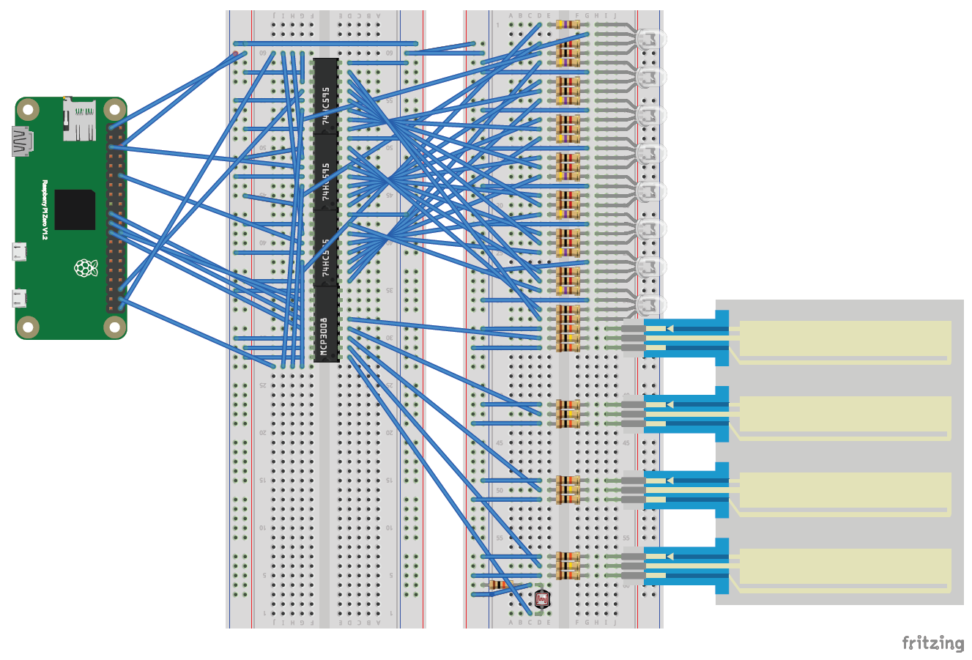

1. KiCAD Schematic

Overview:

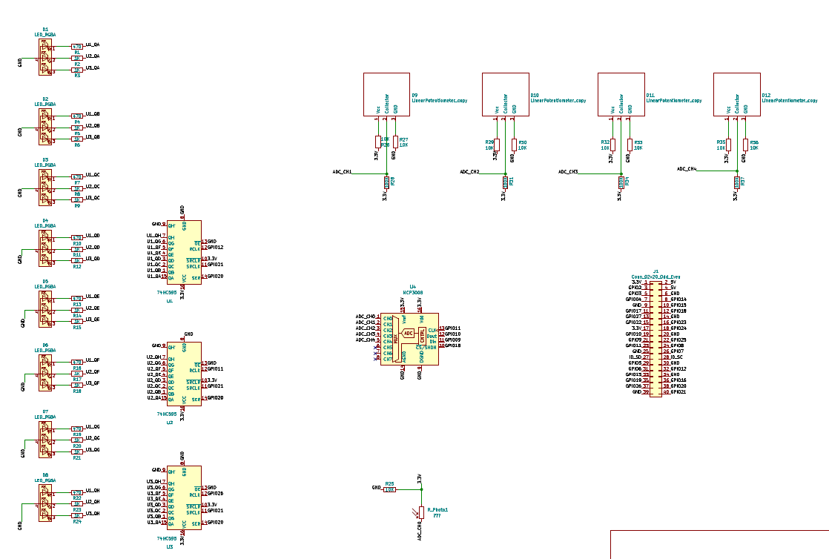

RGB LEDs:

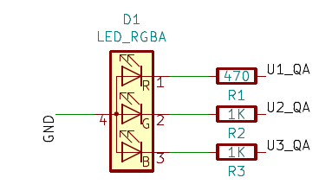

Shift Registers:

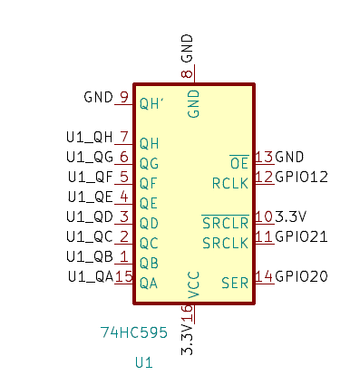

MCP3008 ADC:

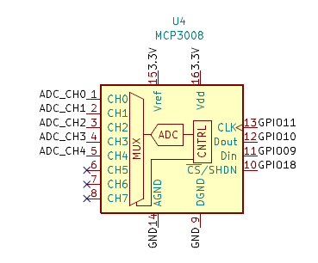

Photoresistor:

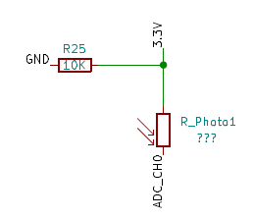

SoftPot:

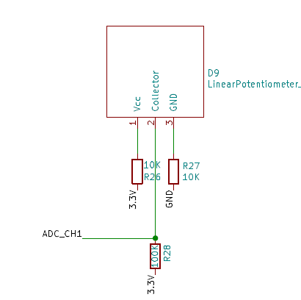

Pi:

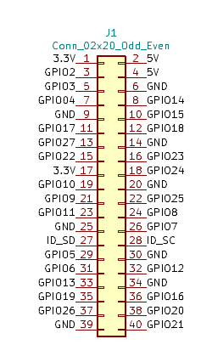

KiCAD PCB View – Top

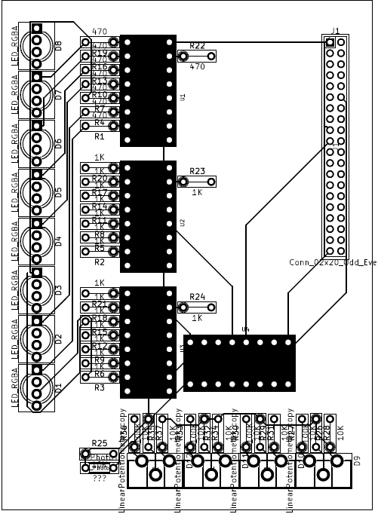

KiCAD PCB View – Bottom

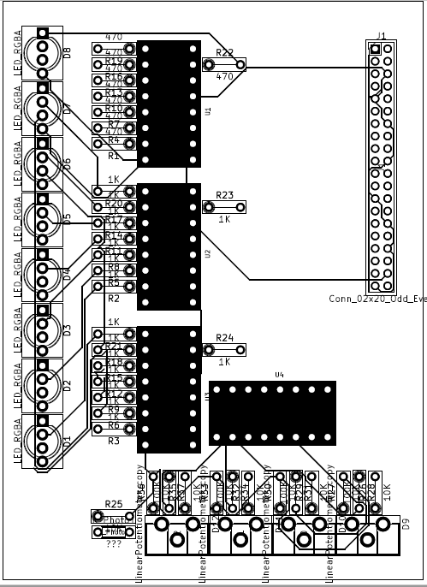

Demo.py

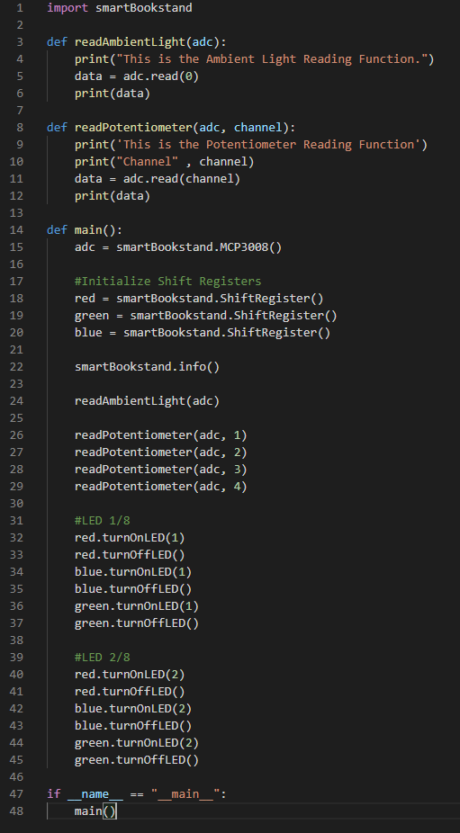

1. Sources Cited

<Market Research>

Search Results on Google Shopping with the keywords “Bookstand+smart”

<https://www.google.com/search?q=bookstand+smart&newwindow=1&safe=strict&sxsrf=ACYBGNSHUK30s2SKF4FlvzAb7oPtsJOXkw:1568665188719&source=lnms&tbm=shop&sa=X&ved=0ahUKEwiig-GaldbkAhWPMd8KHW6JAGwQ_AUIEigB&biw=1920&bih=920>

Search Results on Amazon.com with the keyword “bookstands”

<https://www.amazon.com/s?k=bookstands&s=relevanceblender&qid=1568665057&ref=sr_st_relevanceblender>

<Lab 3 Manual>

<https://newclasses.nyu.edu/access/lessonbuilder/item/29064512/group/3947d0f1-ec3b-401f-86fb-388be6a711b3/Lessons/3:%20Communication%20protocols/Lab%20materials/communication-1.pdf>

<Lab 4 Manual>

<https://newclasses.nyu.edu/access/lessonbuilder/item/29082660/group/3947d0f1-ec3b-401f-86fb-388be6a711b3/Lessons/4:%20Interfacing%20electronics/Lab%20material/interfacing.pdf>

<Shift Register>

sn74hc595 Specification sheet:

<https://newclasses.nyu.edu/access/lessonbuilder/item/29082665/group/3947d0f1-ec3b-401f-86fb-388be6a711b3/Lessons/4:%20Interfacing%20electronics/Lab%20material/sn74hc595.pdf>

Functions and connection take from lab 4 - shift_register.py

<Photoresistor Functions>

<https://tutorials-raspberrypi.com/photoresistor-brightness-light-sensor-with-raspberry-pi/>

Functions to use photoresistor taken from adc.py from Lab 4

GM5539 Specfication sheet:

<https://newclasses.nyu.edu/access/lessonbuilder/item/29056938/group/3947d0f1-ec3b-401f-86fb-388be6a711b3/Lessons/2:%20Input_output%20with%20pins/Lab%20material/photoresistor-GM5539-datasheet.pdf>

<MCP3008>

MCP3008 Class Source: <https://github.com/adafruit/Adafruit_Python_MCP3008>

ADC function taken from lab 4

MCP3008 Specification Sheet:

<https://newclasses.nyu.edu/access/lessonbuilder/item/29082687/group/3947d0f1-ec3b-401f-86fb-388be6a711b3/Lessons/4:%20Interfacing%20electronics/Lab%20material/adc-mcp3008.pdf>

<Linear Potentiometer>

Fritzing diagram taken from: <https://github.com/sparkfun/Fritzing_Parts/blob/master/products/08680_softpot_membrane_potentiometer_50mm.fzpz>

Specification taken from: <https://www.adafruit.com/product/178>

SoftPot data sheet: <https://cdn-shop.adafruit.com/product-files/178/SOFTPOT-DATA-SHEET-Rev-F3.pdf>

<SPI Transfer>

Functions taken from Lab 3 and Lab 4

Enabling SPI1

<https://raspberrypi.stackexchange.com/questions/73346/how-to-enable-spi1-and-spi0-at-the-same-time>

SPI1 pinout diagram

<https://pinout.xyz/pinout/spi>

1. Search Results on Google Shopping with the keywords “Bookstand+smart”  
   <https://www.google.com/search?q=bookstand+smart&newwindow=1&safe=strict&sxsrf=ACYBGNSHUK30s2SKF4FlvzAb7oPtsJOXkw:1568665188719&source=lnms&tbm=shop&sa=X&ved=0ahUKEwiig-GaldbkAhWPMd8KHW6JAGwQ_AUIEigB&biw=1920&bih=920>

   Search Results on Amazon.com with the keyword “bookstands”  
   <https://www.amazon.com/s?k=bookstands&s=relevanceblender&qid=1568665057&ref=sr_st_relevanceblender>